**Week 6 Solutions**

**React**

1. **ReactJS-HOL** .

Create a react app for Student Management Portal named scorecalculatorapp and create a function component named “CalculateScore”

The code and the folder structure is attached in the **Week 6/3 reactjs HOL/** **scorecalculatorapp** folder

**Output :-**

**Chrome – http://localhost:3000/**

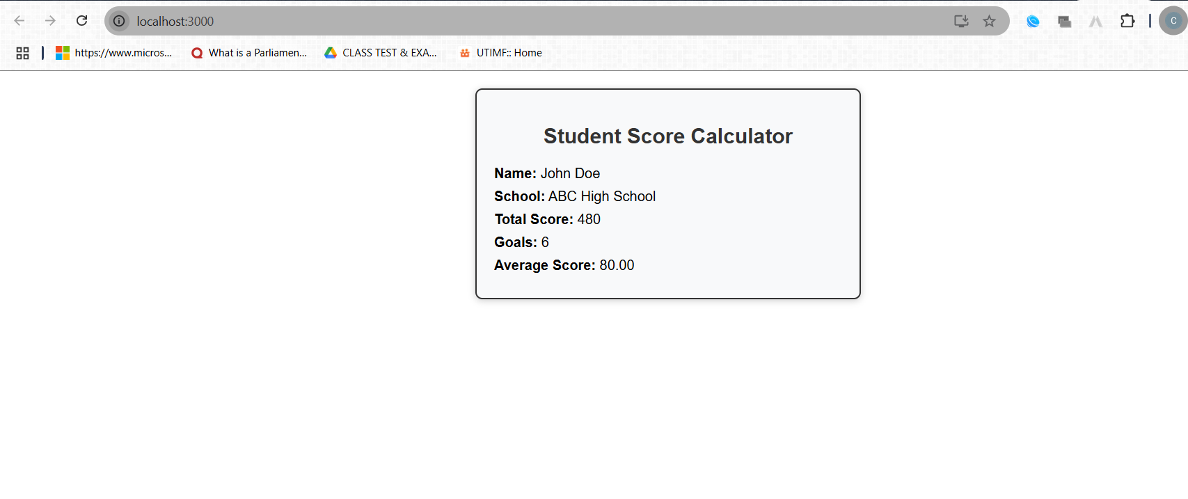

**The hands on file and folder is attached along with it**